How to build a Python development environment on Windows (Python 2.X).

We recommend Anaconda2 and Sublime Text 3. Anaconda is an open-source Python distribution that contains commonly used packages and their dependencies. Sublime Text 3 is a lightweight editor that can run Python code with a few simple Settings.

We take the installation and setting of Anaconda2-5.2.0 (x64) and Sublime Text Build 3211 (x64) as example. Please select x86 or x64 version according to your OS.

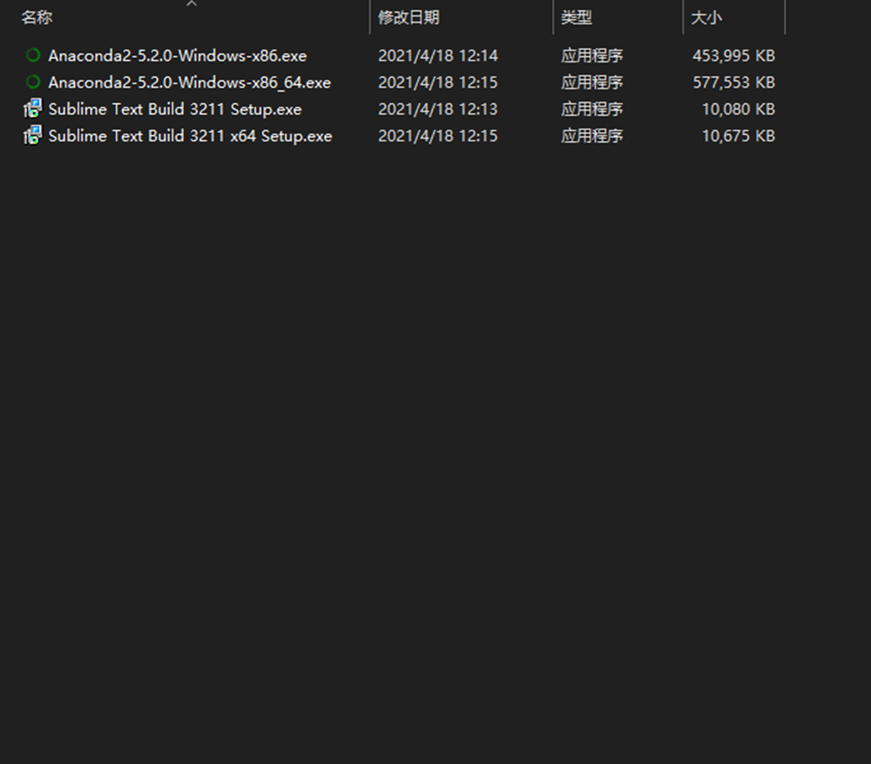

**Anaconda2 installation.**

Double click the downloaded Anaconda2 software.

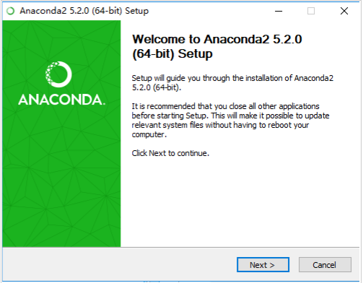

**Click Next**

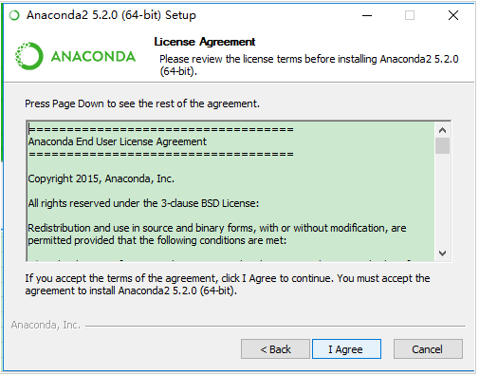

**Click I Agree**

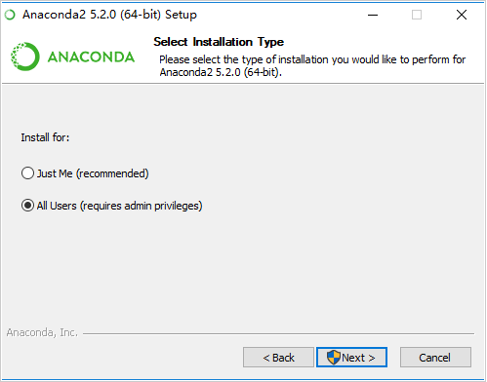

**Click Next**

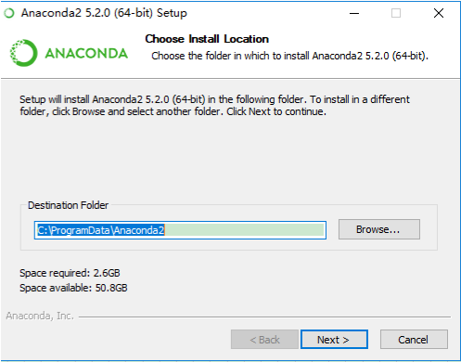

**Click Browse… to select the installation folder (the default folder is recommended), then click Next.**

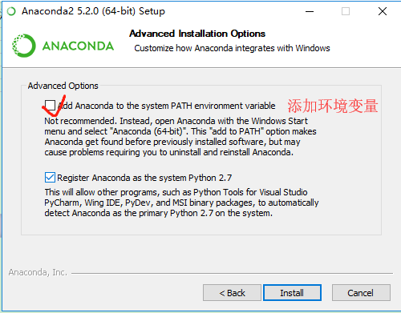

**Tick both options, then click Install.**

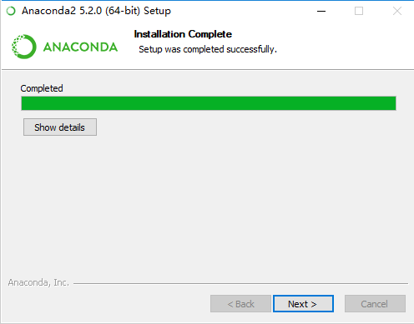

**Wait for installation to complete, then click Next.**

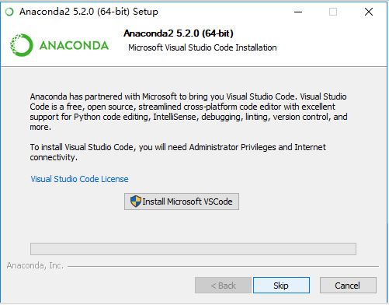

**Click Skip**

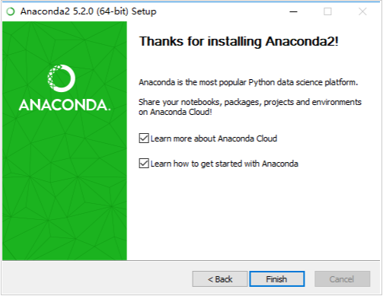

**Click Finish**

**Sublime Text 3**

Double click the downloaded Sublime to install it.

The setting of Sublime.

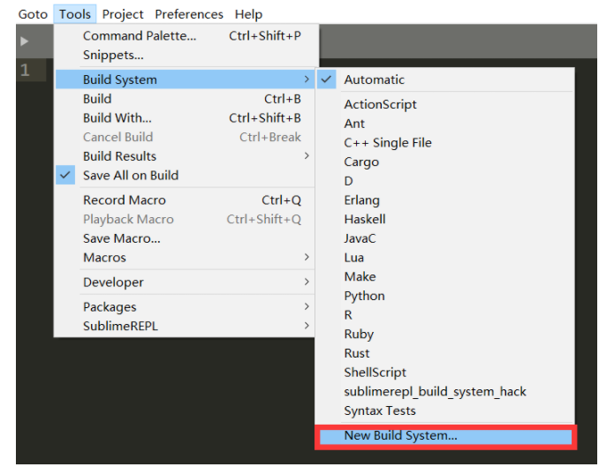

Open the software, click Tools > Build System > New Build System.  
   
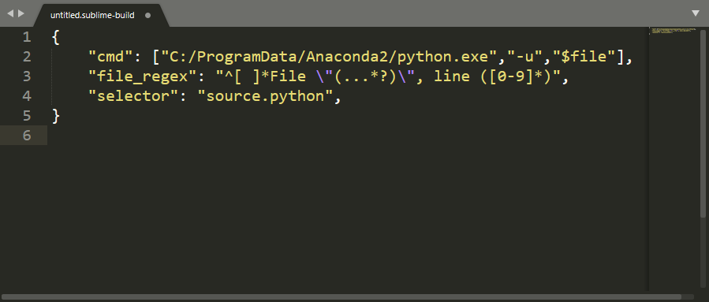

Type the text. Note that you should change the path “C:/ProgramData/Anaconda2/pyhon.exe” according to your own Anaconda installation path.

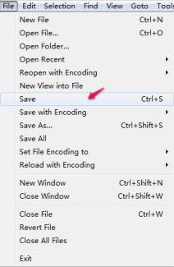

Click File > Save. Note that you have to use the default saving path.

C:\Users\Hesheng\AppData\Local\Temp\1618726372(1).pngRename the file to Python2 and save it.

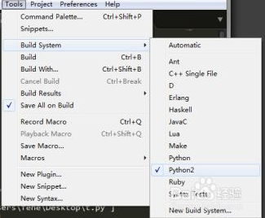

Click Tools > Build System > Python2.

After all the steps are performed, you can use Sublime to run Python code. For example:

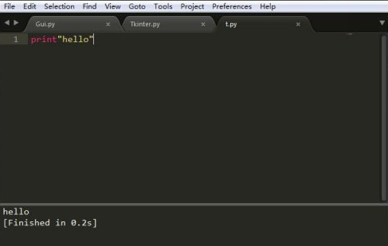

Note that you need to firstly save the code as Python file (ending in the py suffix). Then press “Ctrl + B” to run the code.